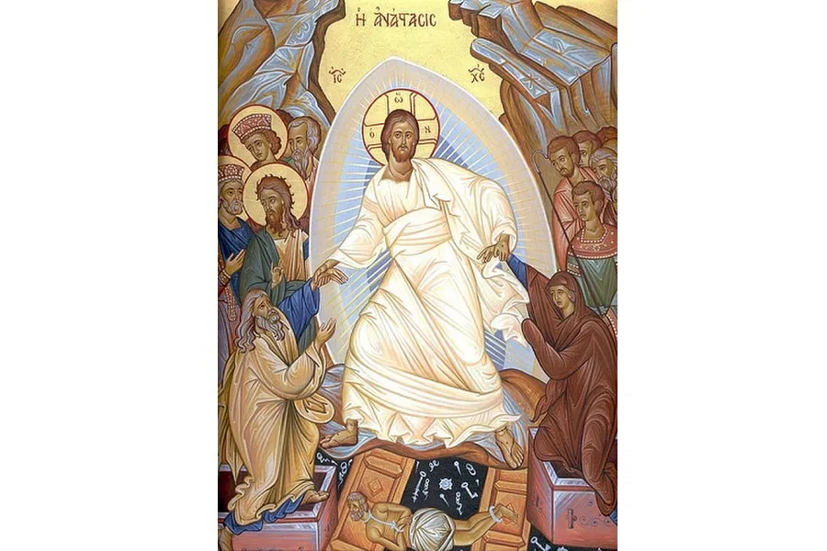

The True Christian Origins of Easter
While Easter today is often associated with colorful eggs, bunnies, and springtime festivities, its true origins are deeply rooted in the life, death, and resurrection of Jesus Christ. Because of this, it is one of the most significant celebrations in the Christian faith. The story of Easter begins with the final days of Jesus Christ’s earthly ministry, often referred to as the Passion. According to the Gospels—Matthew, Mark, Luke, and John—Jesus entered Jerusalem to celebrate the Jewish festival of Passover, a commemoration of the Israelites’ deliverance from slavery in Egypt. During this time, he shared a final meal with his disciples, otherwise known as the Last Supper, where he was betrayed by Judas Iscariot and arrested by Roman authorities. He was crucified on a Friday, an event Christians now call Good Friday, and buried in a tomb provided by Joseph of Arimathea.
The resurrection occurred on the third day, Sunday, when Jesus rose from the dead. The Gospel accounts describe how his tomb was found empty, and how he subsequently appeared to his disciples, proving his victory over death. Early Christians saw Jesus as the fulfillment of the Passover lamb, sacrificed to save humanity from sin, a parallel drawn explicitly in John 1:29, where Jesus is called “the Lamb of God.” This resurrection is the cornerstone of Christian faith, symbolizing hope, redemption, and the promise of eternal life.
Eggs and rabbits also have Christian origins! Eggs, historically dyed red, symbolize the blood of Christ. The breaking of an egg symbolizes the opening of the tomb. Rabbits, symbols of fertility and spring, align with the theme of renewal inherent in The Resurrection.
Despite the layers of cultural accretion—whether pagan or commercial—the true Christian origin of Easter remains unshaken. It is a celebration of the belief that Jesus, through his death and resurrection, conquered sin and death, offering salvation to all who follow him. This message, rooted in the events of that first Easter week nearly 2,000 years ago, continues to resonate with millions worldwide, as affirmed in 1 Peter 1:3: “In his great mercy he has given us new birth into a living hope through the resurrection of Jesus Christ from the dead.”
Easter is the ultimate affirmation of the Christian faith, a testament to the power of God’s love and the hope of eternal life. As the ancient Easter greeting declares: “Christ is risen! He is risen indeed!”
Stay blessed and have a happy Easter!

